Ideation Phase Empathize & Discover

Date | 14 October 2026
Team ID | 23891A0578
Project Name | Medical Diagnosis Center
Maximum Marks | 4 Marks

Empathy Map Canvas
Medical Diagnosis Center – Empathy Map
An Empathy Map Canvas helps us understand the needs, thoughts, feelings, and behaviours of patients in a Medical Diagnosis Center. It helps identify patient problems and improve their overall experience through a simple and user-friendly ServiceNow application.
Says: Patients want easy test booking, timely reports, and online access to their medical records.
Thinks: Patients are concerned about appointment availability, report accuracy, privacy, and delays.
Does: Patients book test appointments, visit the diagnostic center, provide samples, and check report updates.
Feels: Patients may feel worried about delays and frustrated with manual processes. They feel satisfied when appointments are easy to book and reports arrive on time.

Example 1 :
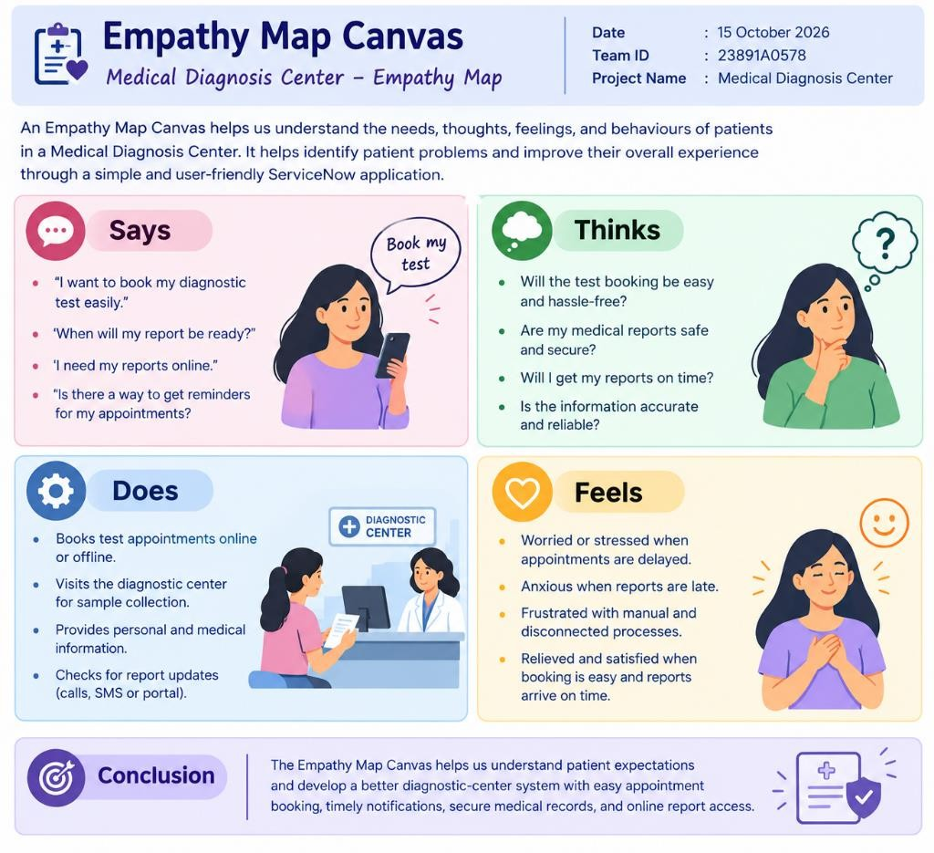

Example 2 :
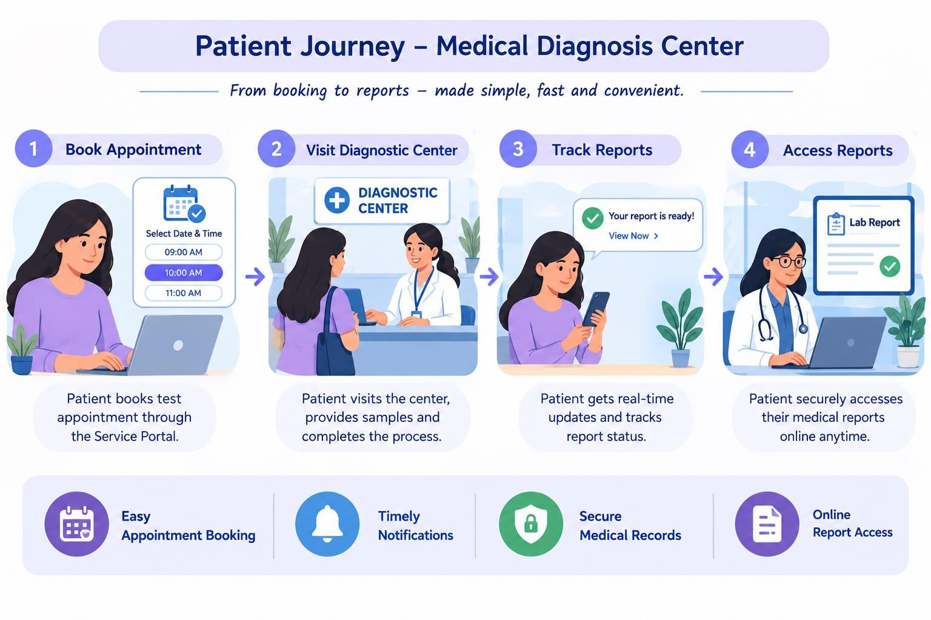

Conclusion:
The Empathy Map Canvas helps us understand patient expectations and develop a better diagnostic-center system with easy appointment booking, timely notifications, secure medical records, and online report access.

